Notes:
4/12/2025 – took much longer than listed because instapot pressure-up time and browning time. Was very very sweet, in part because we only used ½ the soy sauce. I’d suggest avoiding the sugar entirely next time. Also, it’s pretty plain – no veggies, so you need to add those on the side. The egg is also kind of gross because it gets super hard boiled in the instapot.

Prep 10 mins
Cook Time:1hour
Servings: 4
Ingredients
3 green onions/scallions (use only the green part)
- 1 knob ginger (1 inch, 2.5 cm per knob)
- 1 Tbsp neutral oil
- 2 lb pork belly block (or use 3–4 lb, 1.35–2 kg and increase the seasonings by 50%; Japanese grocery stores sell pork belly without the rind; if needed, ask your butcher to remove it)
- 4 soft or hard-boiled eggs (you can use my soft-boiled or hard-boiled egg recipes)
- shichimi togarashi (Japanese seven spice) (for a spicy kick)
For the Seasonings
- ½ cup water
- ¼ cup sake
- ½ cup mirin
- ½ cup soy sauce
- ¼ cup sugar (4 Tbsp)

Japanese Ingredient Substitution: If you want substitutes for Japanese condiments and ingredients, click here.

Instructions

- Gather all the ingredients. My pork belly was from a Korean market and pre-cut into ¼ inch (6 mm) slices. If you buy a pork belly block, you can freeze the meat for 30–60 minutes and cut it with a sharp knife (see my post on how to slice meat). You could also cut it into cubes 2 x 2 inches or 5 x 5 cm, which is a typical Japanese pork belly (kakuni) shape.
- 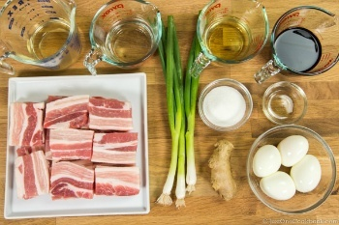
- We will only use the green part of 3 green onions/scallions. Cut the green part in half. (Reserve the white part for another dish like Homemade Miso Soup to serve with this Kakuni.) Peel 1 knob ginger and slice it thinly.
- 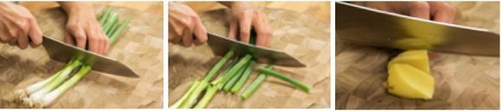
To Cook
- Press the Sauté button on your Instant Pot (I use a 6 QT Instant Pot) or heat your stovetop pressure cooker. Heat 1 Tbsp neutral oil. Add 2 lb pork belly block in a single layer, searing both sides. You may need to work in batches. If so, transfer the seared pieces to a plate and sear the next batch. When finished, put all the seared pork belly back into the pot. Tip: You can skip the searing process to cut down your cooking time, but this step will render more fat and make the dish tastier.
- 
- Pour in just enough water to cover the meat. Then, add the green parts of the green onions and the sliced ginger. Cover and lock the lid. Make sure the steam release handle points at Sealing. Press the Keep Warm/Cancel button on the Instant Pot to stop sautéing. Press the Manual button to switch to the Pressure Cooking mode. Change the cooking time to 35 minutes and start cooking.
- 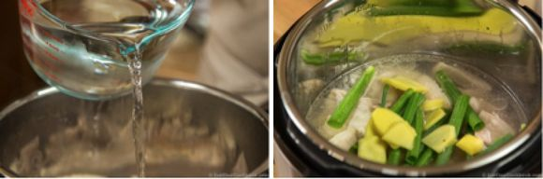
- For a Stovetop Pressure Cooker: Lock the lid and cook on high heat until high pressure is reached. Then, reduce the heat to low to maintain high pressure for about 30 minutes. To cook in a regular pot on the stove, see the end notes.
- When cooking is completed, the Instant Pot will switch automatically to the Keep Warm mode. Either slide the steam release handle to the Venting position to quick release the steam OR let the pressure release naturally (about 15 minutes). Unlock the lid. Drain the cooking water and discard the green onion and ginger. Rinse the pork belly under warm water.
- 
- Put the pork belly back into the Instant Pot. Add ½ cup water, ¼ cup sake, ½ cup mirin, ½ cup soy sauce, and ¼ cup sugar. Mix the seasonings. Add 4 soft or hard-boiled eggs (peeled). Press the Sauté button on the Instant Pot and press the Adjust button to increase the heat. Bring it to simmer to let the alcohol evaporate (only a minute). Then, press the Keep Warm/Cancel button to turn off the Sauté mode. Cover and lock the lid. Make sure the steam release handle points at Sealing. Press Manual and set the cooking time to 10 minutes for sliced pork belly and 20 minutes for pork belly cubes.
- 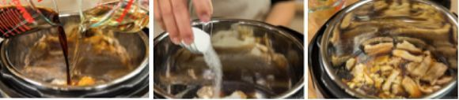
- When cooking is finished, the Instant Pot will switch automatically to the Keep Warm mode. Slide the steam release handle to Venting to let out steam until the float valve drops down. Unlock the lid. Optionally, press the Sauté button and simmer on low heat until the liquid in the cooker reduces by half.
- 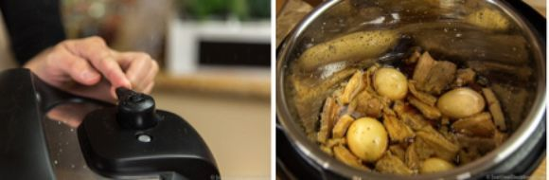
To Serve
- Serve the rice in a individual donburi (large) bowls and pour some sauce from the pot on top. Place the pork belly and egg on top (add some blanched green vegetables, if you‘d like). Pour additional sauce over the meat and serve immediately. If you like it a bit spicy, sprinkle with shichimi togarashi (Japanese seven spice). Enjoy!
- 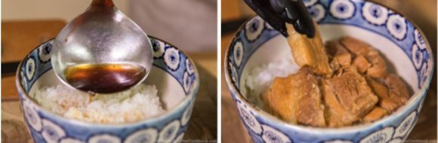
To Store
- You can keep the leftovers in an airtight container and store in the refrigerator for up to 4 days and in the freezer for a month.
Notes
If you are cooking this recipe on the stovetop, cook the pork, the green parts of the green onions, and the sliced ginger in water for 35 minutes. Then, drain and add the seasonings along with ¼ cup of water as moisture will evaporate from the pot. Cook with the seasonings for 20 minutes for sliced pork belly and 30 minutes for pork belly cubes.

Nutrition
Calories: 1325 kcal · Carbohydrates: 10 g · Protein: 29 g · Fat: 126 g · Saturated Fat: 45 g · Polyunsaturated Fat: 14 g · Monounsaturated Fat: 58 g · Cholesterol: 350 mg · Sodium: 905 mg · Potassium: 522 mg · Fiber: 1 g · Sugar: 9 g · Vitamin A: 395 IU · Vitamin C: 3 mg · Calcium: 46 mg · Iron: 2 mg

